Introduction to IT assignment. TO DO: FINSH THIS WORD DOCUMENT and make it intelligent

Upload to bracket and make look pretty with CSS

**Personal Information:** Katelyn Knight, s3839920, [ktlnknight@gmail.com](mailto:ktlnknight@gmail.com), Australian, White, studying bachelor of information technology at RMIT first year and enjoy playing games and socialising.

**Interest in IT:** I am incredibly interested in programming and computers in general. I have always been interested in technology as a child and being surrounded by other people who also liked computers during my final year of high school influenced me to pursue my passions with technology further to turn it into a career in my future.

* I was debating on whether to come to RMIT or go to Monash but RMIT came up on top for its reputation with producing preferred technology students with employers.
* I expect to learn everything essential to be able to have a fulfilling career in my future as well as earning to work well with others and be a preferred candidate for employers.

**Ideal Job:** My ideal job in the IT industry would be in the fields of either an application programmer or a software tester. I will just use application programmer for now.

<https://www.indeed.com/jobs?q=Application%20Programmer&vjk=f4cc2fa2a80af19e>

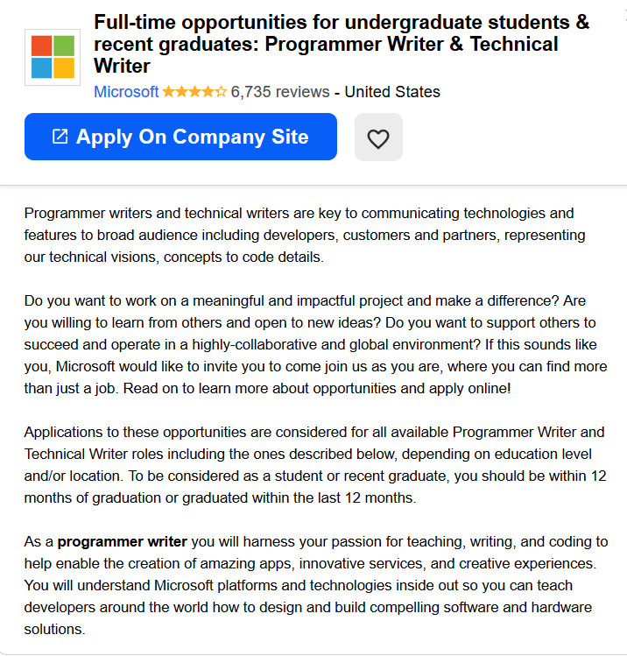 A job in this field sounds most appealing because it makes a difference in the world of technology and it is particularly group orientated which is something I am very interested in participating in as working with others is a window to more opportunities and ideas as well as having the opportunity to be able to make apps and services.

The skills and qualifications include being fluent in various languages such as C/C++/C#/Java for a programmer writer, considerably above average writing skills and a bachelor’s degree in engineering, computer science or related field. There is no previous experience needed but it is preferred.

I currently have next to none of the qualifications required for this position but that is why I am enrolled in an information technology degree. I plan on working as best as I can to build skills and qualifications as needed. I also plan on making programs in my free time to build fluency and familiarity in coding.

**Profile:**

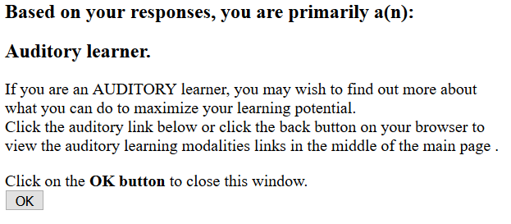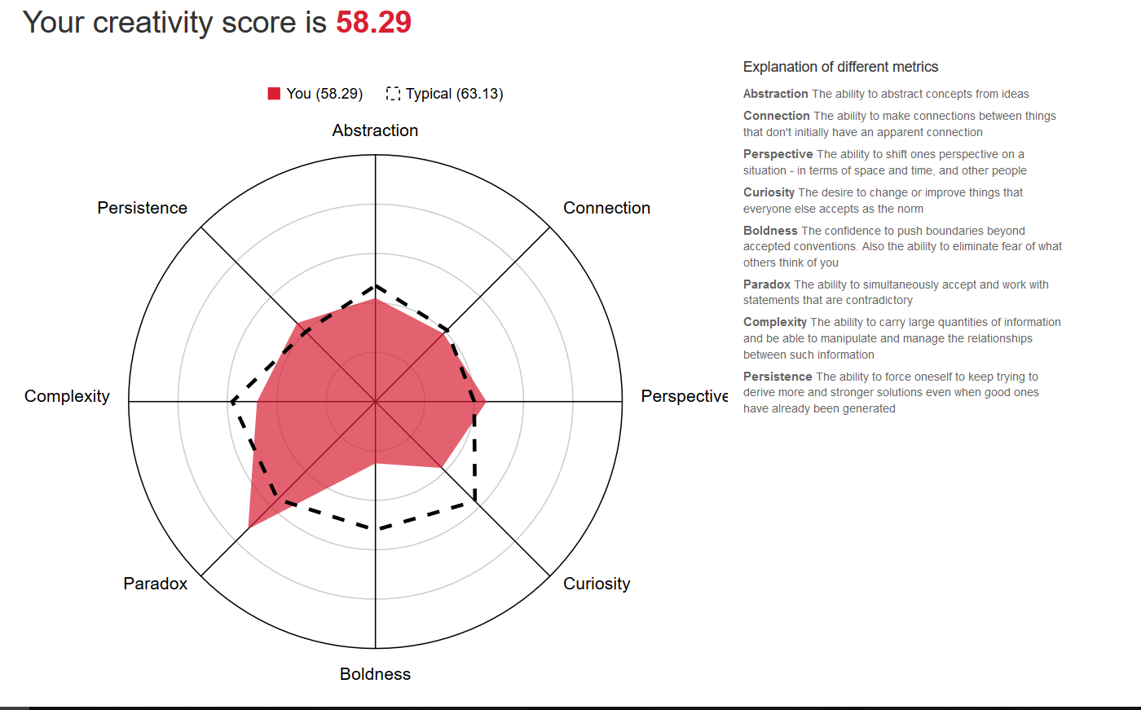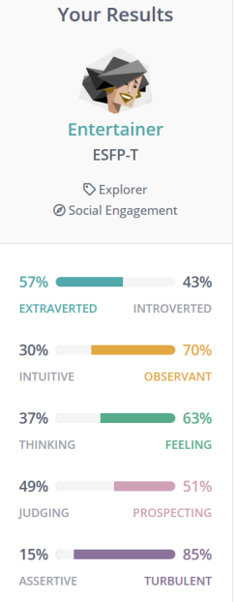These results have been an eye opening in the way I know myself, especially with the way I learn, I never thought about the way I learnt but knowing I am possibly more on the auditory side I can use this is further the way I learn to better my skills for my future. I additionally feel as though my personality type will benefit the workforce.

The results from the test positively influence my behaviour in a team, as I love to work with people to get jobs done as it brings insight from people all around the world and workforces.

I think these results will benefit the team as I am able to pick up more auditory queues wen working with a group. When forming a group, I would choose to have personalities of different types as well as people who learn in different ways.